In this task I have written the code for Double bottom and double top by using some mathematical functions of scipy library and then I have written the code for Bollinger bands and then I have generated the sell signals for it. Then I have found the common points where they have common sell or buy signal.

For the strategy part I have allocated a capital of 10000000 rupees and I have applied the logic that whenever we are getting a common buy signal we are only using 65% of the capital with us for buying the stock and when we are getting a common sell signal we selling only 40% of the stocks available with us.

Here is once double bottom I have plotted

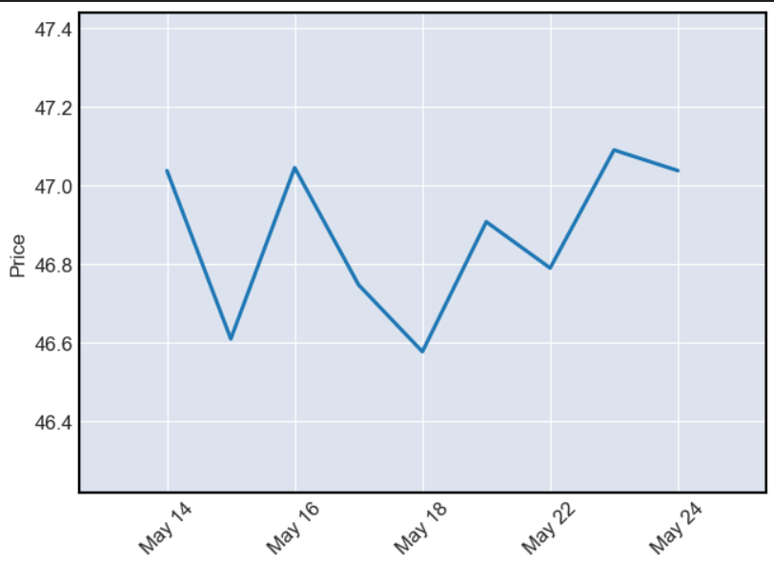

Here is the candle stick graph for this double bottom

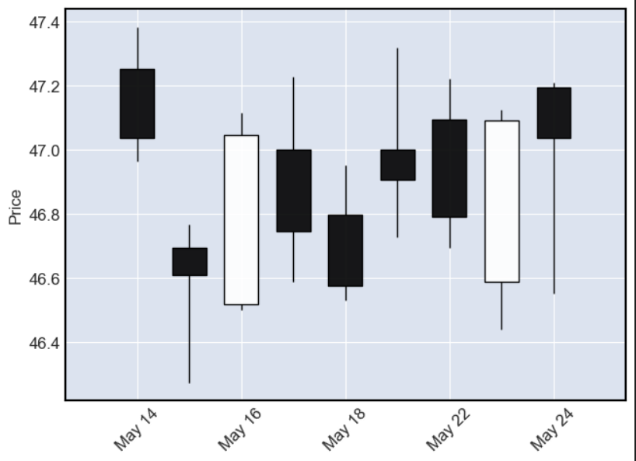

I have used mplfinance library to plot these graphs.

Here is the buy sell generation through double-top and double-bottom

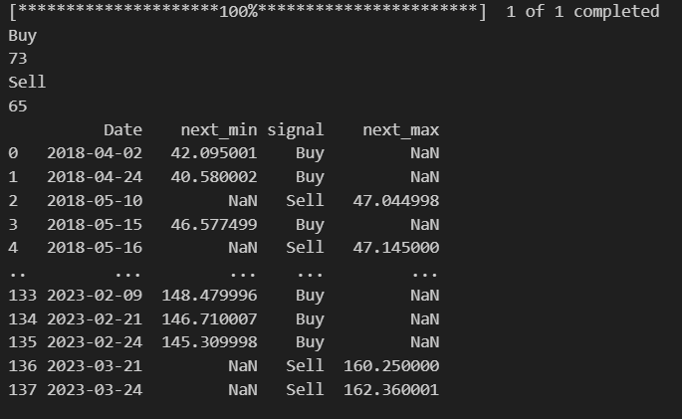

Here is the buy sell generation through Bollinger Bands Strategy

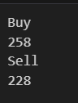

Here are the returns after combining both

